Product Description

1. OBDSTAR X-100 PRO Auto Key Programmer (C+D) Type
2. With X-100 PRO, Without worries about Matching!
3. X100 PRO C+D Type function: Immobilizer remote match+ Odometer+ OBD Software
4. X-100 PRO Auto Key Programmer is a kind of handheld device for programming keys in immobilizer units on vehicles. This scan tool has a simple and robust design, to make your vehicle service experience much easier!

**OBDSTAR X100 PRO Auto Key Programmer (C+D) Type for IMMO+Odometer+OBD Software Get OBDSTAR PIC and EEPROM 2-in-1 Adapter Free**

**Top 8 Reasons to Get OBDSTAR X-100 PRO Auto Key Programmer:**

**1. Original from OBDSTAR, Support EEPROM Function, with OBDSTAR PIC and EEPROM 2-in-1 Adapter free in package**  
**2. Free Update Online on OBDSTAR Official Website for 1 Year, 90usd/year after 1 Year**  
3. Inherited the overall look of the original X100 +, changed the new silicone button, feel more comfortable

4. Adjusted the TF card slot position in mold, fit more tightly than previous generation, card plug will not go inside the machine

5. Software downloading speed is improved by more than 50%

6. New upgraded software operating system, added operating interactive prompt

7. High-capacity 4G TF card, more stable performance, never appear white screen

8. New design of PCB hardware, greatly improved configuration

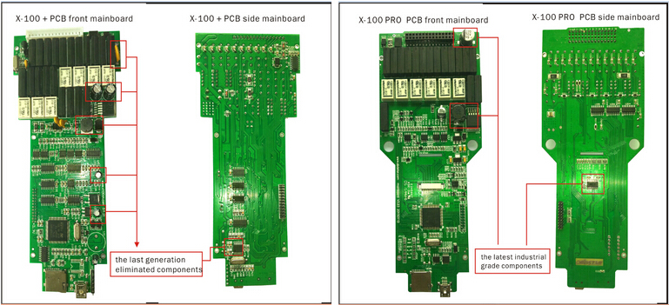

**Notice:  
1. Language:**English  
**2. Dealer Code:**860755B1  
**3. Configuration(C+D): IMMOBILISER+ OBD Software and Odometer Adjustment + OBD Software  
4. Not Support Toyota G Chip**

**OBDSTAR X100 Pro Features:**

1. New keys programming

2. Reads keys from immobilizer's memory

3. New immobilizer programming

4. New ECU programming

5. New mechanical key number programming

6. Vehicle Identification Number programming

7. Reset ECU&reset immobilizer

8. Easy to operate by the guided menu programming

9. New remote controller programming

10. Immo PINCODE reader

11. Odometer ajustment(Via obd)

12. With full and strong database for the most important vehicle makes

13. Upgradeable via web-based download

14. EEPROM Chip read

**X-100 Pro Vehicle Coverage:**  
  
**EEPROM Adapter:** EEPROM ADAPTER V30.40  
**Immobiliser:** ACURA, AUDI, BAIC, BESTURN, BRILLIANE, BYD, CHANGAN, CHANGHE, CHERY, CHRYSLER, CITROEN,  DFLZ, DFPV, DS, FORD, GEELY, GM, GREATWALL, HAFEI, HAIMA, HAWTAI Motor, HONDA, HONGQI, HUAPU, HYUNDAI, INFINITI, JAC, JAGUAR, KIA, LANDROVER, LEXUS, LIFAN, LINCOLN, LUFENG, MAZDA, MG, MITSUBISHI, NISSAN, OPEL, PEUGEOT, PORSCHE,  RENAULT, ROEWE, SAIC ENGLANG, SEAT, SKODA, SMART, SSANGYONG, SUBARU, SUZUKI, TOYOTA, VW, YOUNGLOTUS, ZZMAZDA, ZZNISSAN;  
**OBDII:** OBDII V30.02 for diagnose  
**Odometer:** AUDI, VW, BENZ, Chrysler, Ford, GM, Porsche, Skoda, Seat

And the more cars’ software will be released.  
**Remark:**including X-100+ all the matching function and add new software function in X-100 PRO. **Do not include Proton this car model**

**OBDSTAR X100 Pro Packing List:**

1pc x X-100 RPO Main Unit

1pc x OBDII-16 Connector

1pc x HONDA-3 Connector

1pc x HYUNDAI/KIA-10 Connector

1pc x KIA-20 Connector

1pc x Main Cable

1pc x TF Card

1pc x TF Card Reader

1pc x X-100 PRO User Manual  
1pc x OBDSTAR PIC and EEPROM 2-in-1 Adapter